Other Communities Using PRAT  Wisconsin Dells  Lake Delton  Bayfield  Eagle River  Stockholm  Rhinelander  Tomahawk (pending)  Minocqua (pending)  If you shop in Ironwood, you are already paying 6% sales tax.  On a $100 transaction, PRAT paid is 50¢  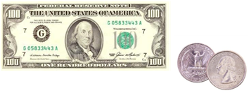  Links to PRAT Resources  Visit www.revenue.wi.gov and type in keyword “premier resort” for SIC Codes and other information.  Additional information can be found on the Town of Mercer webpage at townofmercer.com |  |  | Upcoming Informational Meetings:  January 11, 2021 @ 5:00pm  January 21, 2020 @5:30pm  Location:  Mercer Community Center  2648W Margaret St  Contact Us  Town Office  Phone: 715-476-2403  Email: tomiron@centurytel.net  Web: townofmercer.com  Chairman John Sendra  Cell: 715-904-8888  Town of Mercer  2657 Railroad St  Box 149  Mercer WI 54547 |  |  | Town of Mercer  - Premier Resort Area Tax (PRAT Tax)

What is PRAT?  PRAT stands for Premier Resort Area Tax. Pursuant to ss. 66.1113 Wis. Stats., it’s a retail sales tax authorized by Wisconsin State Legislature. It requires certain retailers related to the tourist industry to collect an additional sales tax.  Adoption of PRAT allows the town to utilize a tool created by the legislature for communities like ours to share the expense of maintaining our local transportation infrastructure.  How Does PRAT Work?  The PRAT rate would be one half cent on the dollar (0.05%) and would generate revenue from a broad cross section of people using town facilities, not just property owners. Similar to a user fee, PRAT helps spread infrastructure costs among all users.  The tax is collected by the retailer at the same time state sales tax is collected and paid to the Department of Revenue, which then returns the PRAT proceeds to the town.  What can PRAT Tax be used for?  If approved, PRAT funds would be restricted to infrastructure-related projects such as road construction and maintenance, culverts, curbs, sidewalks, street lighting, and public safety expenditures as authorized and defined by Wis State Statute 66.1113(1)(a). Funds could NOT be transferred for use in other departments or earmarked for non-infrastructure purposes. |  |  | Why a PRAT?  Mercer’s year-round population is under 1,445. But much of the year the tourist and transient population in our town is many times greater.  This makes it necessary for the town to provide service (such as ambulance, fire and library) on a much larger scale than what would be required by the local population.  Mercer has 95 miles of paved town roads and a total of 159.4 miles of town roads. Over the past decades, state road aids have not kept pace with the cost of construction. At the same time, the Mercer Town Board has sought to minimize any increase to the town’s tax levy.  So, in order to properly reconstruct and maintain town roadways, it must be decided how to raise revenue. PRAT is one way of doing that, instead of relying only on increases to general property taxes.  Mercer Public Works Department has identified approximately 2.3 million in infrastructure projects that could be justified for completion in the next 5 years. In addition to local residents, this infrastructure is used and relied upon by transient guests and visitors from both near and far.  If approved, the Wisconsin Department of Revenue estimates that Mercer’s annual PRAT revenue would total approximately $250,000. In order for the town to raise an equivalent amount of revenue via property taxes it would have to increase the tax levy by nearly $52 per $100,000 valuation. |  |  | What is subject to PRAT Tax?  “Tourism-related retailers” as stated in Wis State Statute 66.1113(1)(d). For a complete list of items view the SIC codes using the link provided in this flyer.  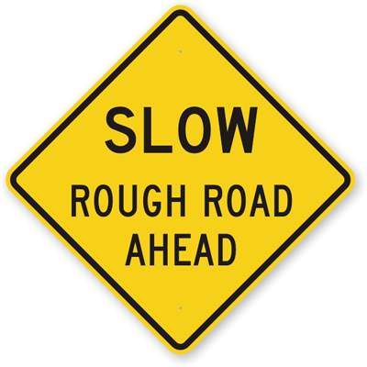  Road Re-Paving Rate  Taking the town’s total miles of roads (159.4) and the town’s current road construction budget of $250,000, it would take the town about 53 years to re-blacktop all roadways in town.  If approved, the additional PRAT revenue would make it possible to reduce that cycle to 26 years. Additionally, the town would have the option to accelerate the road schedule even further by borrowing for larger road construction packages and using PRAT revenue for repayment.  What Will the Referendum Look Like?  “Should the Town of Mercer levy .05% (one half cent on the dollar) sales tax on tourist related retailers, as described in Wisconsin State Statute 66.1113(1)(d) to pay for transportation and public safety infrastructure expenses? YES or NO”  If passed by voters, the referendum then goes to the statue legislature for approval.  The earliest PRAT would be implemented is 2023.

